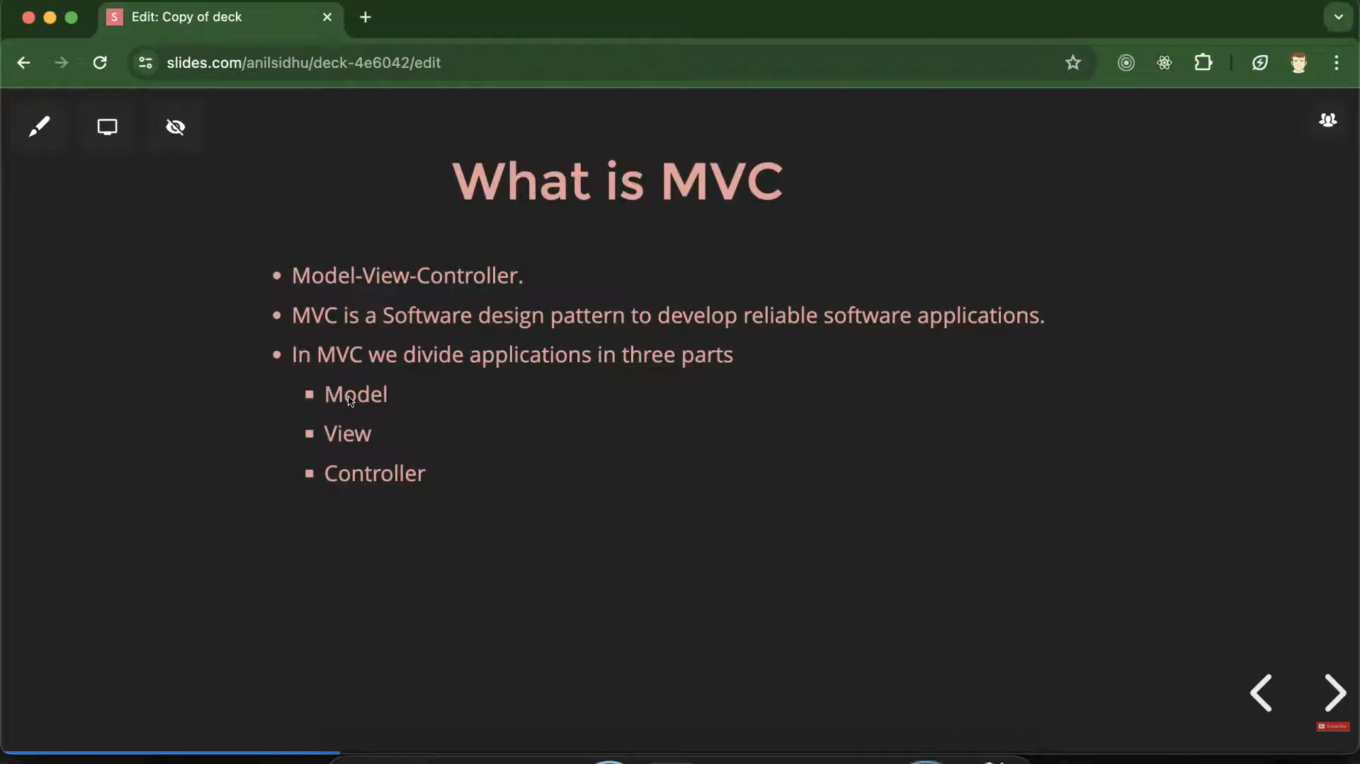
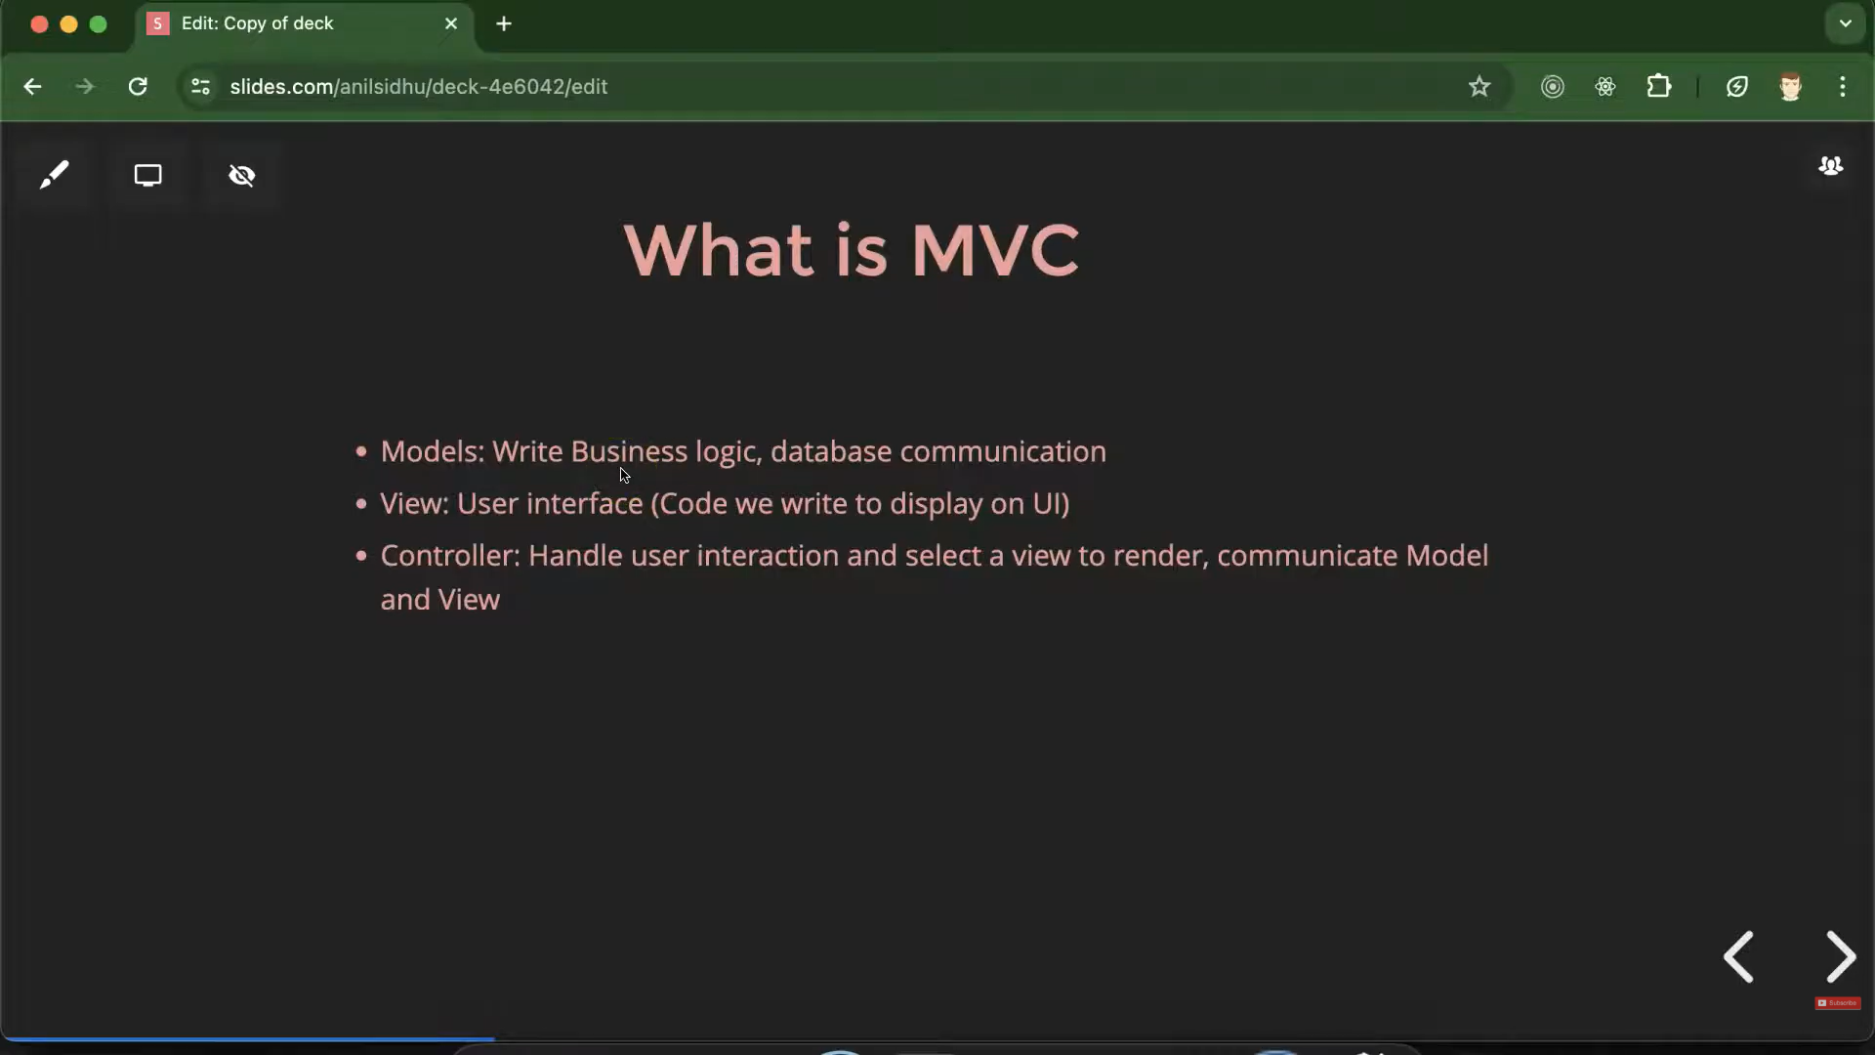
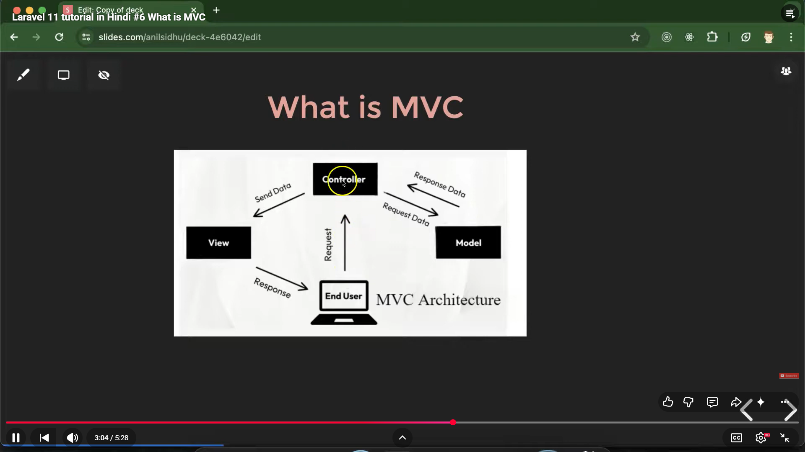

Laravel follows MVC pattern
File and folder structure in Laravel:
Q: What is the Difference between composer.json and composer.lock?
Ans:- The main difference is that composer.json defines the rules for which packages you want, while composer.lock records the exact versions that were actually installed.
Vendor folder is a folder which stores actual source code of the installed dependencicies or packages
Feature | composer.json | composer.lock | vendor/ folder
What is it? | The Shopping List | The Receipt | The Groceries
Content | The names and version ranges you want. | The exact versions that were actually downloaded.  It also notes the dependency of dependency exact versions too (a package uses library and that library uses another library.) | The actual source code files.
Who creates it? | You (the developer) | Composer (automatically) | Composer (automatically)
Purpose | To define dependencies. | To ensure every environment is 100% identical. | To store the code your app uses to run.
Commit to Git? | Yes | Yes | No (because it’s too large)

- Composer.json is created either manually or with the help of a command, when u write commands such as composer init or composer require <package name>(to install any package or dependency).
- If you run composer require <package-name> in a folder that doesn't have a composer.json yet, Composer will automatically create a basic one for you and add that package to it
- In composer init an interactive wizard that asks for your project name, description, author, and initial dependencies. Once you finish the questions, Composer generates the composer.json file for you.

Q: Difference between composer.json and package.json?
Ans:- - composer.json (The PHP Manager) which manages libraries and Laravel-specific packages (like Eloquent filters, debug bars, or payment SDKs).
- Package.json (The javascript manager) which manages frontend tools, CSS frameworks, and JavaScript libraries needed for your UI.

- App folder is a folder which store the core code of your own project in which u are working on. This keeps models, controller, service provider and middle ware and all
- The routes folder is the central hub for defining how users interact with your Laravel application. It maps incoming URLs (like /home or /api/users)(web.php) to specific logic, such as controllers or closures. Console.php is for terminal when we use terminal to give commands
- View folder (which is sub-folder of resources file) handle’s the UI part (this is v(view) in MVC).
- config folder refers to the settings, parameters, and options used to define how a software system behaves without changing its source code.
- In the context of Laravel, this separation means you can move your website from a local laptop to a live server and change only the files in the config folder (or the .env values they reference) to make it work in the new environment. Note:-u have database connection here while the database folder manages your data architecture and initial state.

- Public folder contains index.php which the first file that gets executed by the server
- Favicon.io file is responsible for the  that black (HR) box icon in hacker rank tab in browser tab
- Storage folder contains the the files u create in your projects files such as pdf files , it also strores cache and all too.
- Note:- Unlike the public folder, the storage folder is not accessible to the web by default. This keeps your private PDFs and system cache files secure.

- Inside this storage folder there is also a file name logs, A log file in Laravel is a record of everything that happens behind the scenes in your application. It primarily captures errors, system events, and manual debug messages to help you understand how your app is performing and why things might be breaking.

- .env file is an important files which contains credentials, api keys and all and u must include this in .gitignore file so that it do not go public for security reasons

- Vite.config.js creates a local deployment server when we use react, view index.js and all.

Routing in Laravel:

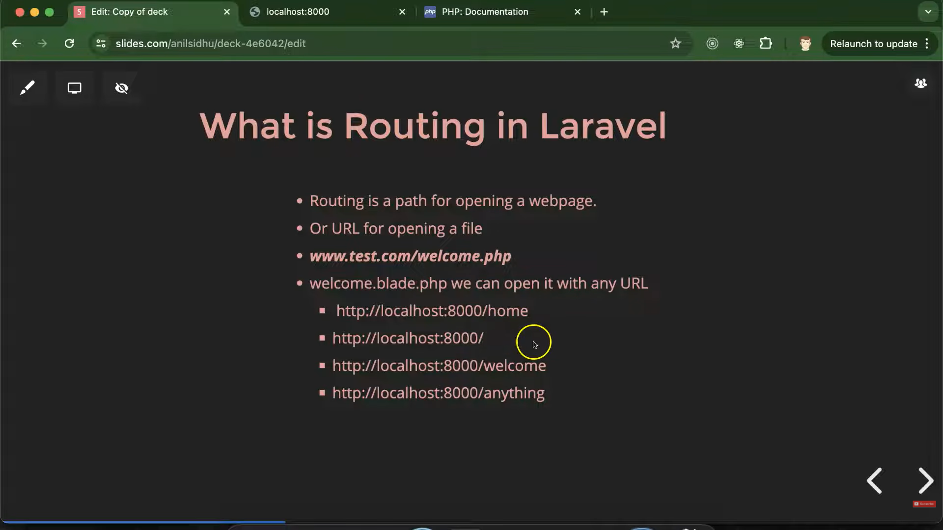

Controller in Laravel:
- In Laravel, a Controller acts as the "middleman" or the "brain" between your Routes and your Database.
- Instead of writing all your logic directly in the routes/web.php file (which makes it messy), you move that logic into a Controller class.
Note:- Always name the controller first letter capital because it is a class. not necessary but it’s a standard so follow it.
Syntax to make a controller using cli:-
php artisan make:controller controller name
- Always make controller with the help of command line because its’s easy and professional way
Syntax to Route a controller:-
use App\Http\Controllers\controller name;
Route::get('/path or profile', [controller name::class, 'method or function name ']);
Ex:
use App\Http\Controllers\UserController;
Route::get('user',[UserController::class,'getUser']);

